**2/25/2020 BARN Large 3D Printer Electrical Log**

1. Energized the Duet WiFi control board via the Power In 12-24 V terminals from the Eagwell 24VDC, 360 Watt power supply, to verify operability and to check board input current via the inline wattmeter I installed. Found load current to be around 110 mAmps. At 24.2 VDC. De-energized the Eagwell power supply and disconnected the 24VDC from the board to prepare to test the board’s USB interface**, note that the USB interconnect is not to be concurrently installed with external DC power applied to the board’s 12-24 V terminals.**
2. Loaded YAT terminal control program on my PC and connected a micro USB to USB cable between the Duet WiFi board and an USB port on my PC. YAT was unable to connect to the board via the USB interface, even though the Blue onboard USB LED was illuminated. At this point, a different USB-to-micro USB cable was installed with no change. The supplied and installed micro SD card was then removed and at that time, YAT was able to connect with no card inserted on COM3. The removed micro SD card was then installed in an SD card carrier and inserted into the PC SD card slot and was found to be unreadable. A different micro SD card was then acquired and formatted, but not installed. An M115 command was then sent via YAT to the board to determine its firmware version, which was reported back as:

**Firmware Version: 2.0 (RTOS)**

**Duet WiFi: 1.02**

**Firmware Date: 2018-06-05b3**

1. The Duet “Installing and Updating Firmware” page: (<https://duet3d.dozuki.com/Wiki/Installing_and_Updating_Firmware>)

was then consulted to identify the latest firmware versions for our Duet WiFi board. Based upon this, the latest version was found to be release 2.05.1 (Duet2), 1,26.1 (Duet 06/085). The micro SD card to be installed in the Duet board’s micro SD card slot is required to have a specific file configuration for /sys and /www files. The /sys file config on the SD card is as follows:

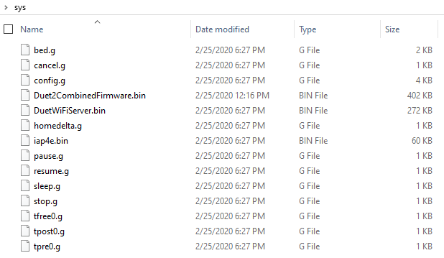

The /www file configuration on the SD card is as follows:

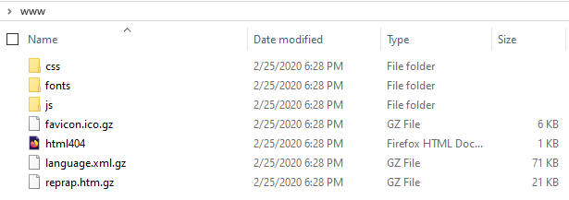

It should be noted that the file ***DuetWiFiServer.bin*** was renamed from its downloaded file name ***DuetWiFiServer-1.23.bin*** as directed*: “They must have exactly those filenames, so if the files you downloaded had* ***the version number*** *included in the filename, then you will need to rename them”.* The configured SD card was then installed in the Duet WiFi slot.

1. At this point, the YAT terminal was used to send the ***Install Main Firmware*** command: **M997 S0** which then installed the main firmware. Then, the YAT terminal was used to send the ***Install* *WiFi Module Firmware*** command: **M997 S1** which then installed the WiFi Module firmware. To verify that these firmware upgrades were indeed installed, YAT terminal was used to send the ***Firmware Version Query*** command: **M115**, giving the following reply:

**FIRMWARE_NAME: RepRapFirmware for Duet 2 WiFi/Ethernet FIRMWARE_VERSION: 2.05.1 ELECTRONICS: Duet WiFi 1.02 or later FIRMWARE_DATE: 2020-02-09b1**<LF>**ok**<LF>

The YAT terminal was then used to send the ***WiFi Firmware Version query*** command: **M122** giving the following reply:

**=== Diagnostics ===**<LF>**RepRapFirmware for Duet 2 WiFi/Ethernet version 2.05.1 running on Duet WiFi 1.02 or later**<LF>**Board ID: 08DJM-9178L-L4MSJ-6JKD4-3SN6T-1T1YQ**<LF>**Used output buffers: 1 of 24 (1 max)**<LF>**=== RTOS ===**<LF>**Static ram: 25712**<LF>**Dynamic ram: 92836 of which 164 recycled**<LF>**Exception stack ram used: 312**<LF>**Never used ram: 12048**<LF>**Tasks: NETWORK(ready,1448) HEAT(blocked,912) MAIN(running,3816) IDLE(ready,160)**<LF>**Owned mutexes:**<LF>**=== Platform ===**<LF>**Last reset 03:16:20 ago, cause: power up**<LF>**Last software reset at 2019-11-23 20:35, reason: User, spinning module GCodes, available RAM 6404 bytes (slot 1)**<LF>**Software reset code 0x0003 HFSR 0x00000000 CFSR 0x00000000 ICSR 0x0041f000 BFAR 0xe000ed38 SP 0xffffffff Task 0xffffffff**<LF>**Error status: 0**<LF>**Free file entries: 10**<LF>**SD card 0 detected, interface speed: 20.0MBytes/sec**<LF>**SD card longest block write time: 0.0ms, max retries 0**<LF>**MCU temperature: min 16.3, current 25.0, max 27.1**<LF>**Supply voltage: min 1.5, current 1.7, max 1.7, under voltage events: 0, over voltage events: 0, power [Warning: Maximal number of bytes per line exceeded! Check the EOL (end-of-line) settings or increase the limit in the advanced terminal settings.]**

1. At this point, the YAT terminal was used to send the ***Add WiFi host network to remembered list*** command**:** **M587** **S"ccc"** Network SSID **P"ccc"** Network password, adding the identified host network. The YAT terminal was then used to send the ***Set IP address, enable/disable network interface*** command: **M552 S1** which illuminated the BLUE wireless LED and connected the Duet to the host network. The below image details the Duet WiFi board at this point, the left-most GREEN LED indicating available 5 VDC, the right-most GREEN LED indicating 3.3 VDC available, the left-most BLUE LED indicating USB connected and the right-most BLUE LED indicating WiFi activated.

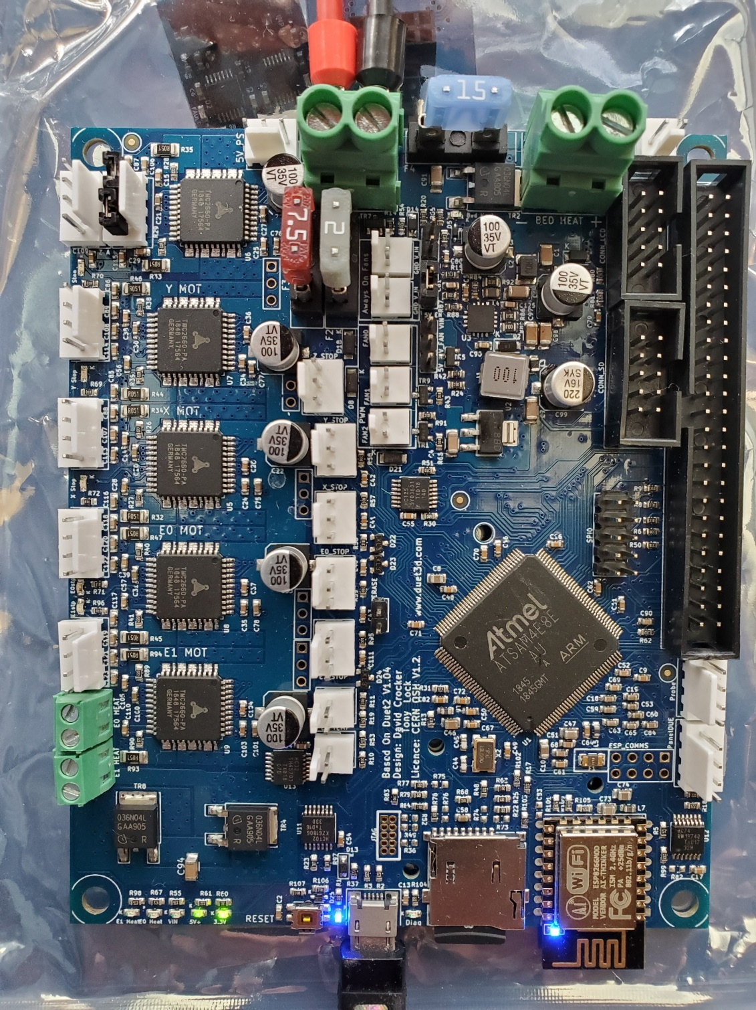

Duet WiFi Board Energized VIA USB

1. Referencing the Duet Wiki: [**https://duet3d.dozuki.com/Wiki/Gcode**](https://duet3d.dozuki.com/Wiki/Gcode)**,** the following M commands were used VIA YAT to command the Duet WiFi board:

**M115: Get Firmware Version and Capabilities**

**Parameters**

* *This command can be used without any additional parameters.*
* **Pnnn** Electronics type (See Notes)
* **Bnnn** Board number (RRF_3/Duet 3 only, see Notes)

**Examples**

* M115
* M115 P2

Request the Firmware Version and Capabilities of the current microcontroller.

The details are returned to the host computer as key:value pairs separated by spaces and terminated with a linefeed.:

M115

FIRMWARE_NAME: RepRapFirmware for Duet 2 WiFi/Ethernet FIRMWARE_VERSION: 2.04RC1 ELECTRONICS: Duet WiFi 1.0 or 1.01 FIRMWARE_DATE: 2019-07-14b1

See the M408 command for a more comprehensive report on machine capabilities.

**Notes**

The 'P' parameter is used tell the firmware about the hardware on which it is running, if RRF can't identify it. Should only be used in config.g, if you're having problems. If the P parameter is present then the integer argument specifies the hardware being used. The following are supported on first-generation Duets:

* M115 P0 - Automatic board type selection if supported, or default if not
* M115 P1 - Duet 0.6
* M115 P2 - Duet 0.7
* M115 P3 - Duet 0.85

The 'B' parameter is used on Duet 3 only, using RRF_3. M115 can take an optional B (board number) parameter which is the CAN address of the board to be queried, default 0 (i.e. main board). Example:

M115 B1

Board EXP3HC firmware 3.0beta1 2019-10-28b1

**M122: Diagnose**

**Parameters**

* *This command can be used without any additional parameters.*
* **Pnnn** report specific information (See Notes)
* **Bnnn** Board number (RRF_3/Duet 3 only, see Notes)
* **"DSF"** Immediate DSF diagnostics (RRF_3/Duet3 only with attached SBC)

**Example**

* M122

Sending an M122 causes the RepRap to transmit diagnostic information.

**Notes**

The 'P' parameter is used to report specific information. The details vary between releases. As at RepRapFirmware version 2.03 they are:

* P1 print summary test report (additional parameters: Taa:bb = min/max accepted MCU temperature reading, Vaa:bb = min/max VIN voltage reading, Waa:bb = min/max 12V regulator voltage reading if applicable)
* P100 print a summary of recent moves (only if move logging is enabled in the firmware build)
* P101 print the status of an attached DueX expansion board
* P102 print how long it takes to evaluate the square root of a 62-bit unsigned integer
* P103 print how long it takes to evaluate sine and cosine
* P104 print how long it takes to write a file to the SD card (specify the file size in Mbytes in the S parameter, default 10)
* P105 print the sizes of various objects used by RepRapFirmware

Note: do not use M122 with a P parameter of 1000 or greater. There are a few values that deliberately cause the firmware to crash, which are used to test the error reporting facilities. As at firmware 2.03 these are:

* P1001 cause a watchdog reset
* P1002 test what happens when a module gets stuck in a spin loop
* P1003 test what happens when we write a blocking message to USB
* P1004 test integer division by zero
* P1005 test the response to an unaligned memory access
* P1006 test the response to accessing an invalid region of memory

The 'B' parameter is used in RepRapFirmware 3 on Duet 3 only, to report diagnostic information from connected boards. The B (board number) parameter is the CAN address of the board to be queried, default 0 (i.e. main board). Example:

M122 B1

Diagnostics for board 1:

Board EXP3HC firmware 3.0beta1 2019-10-28b1

Never used RAM 163.4Kb, max stack 376b

HEAT 1284 CanAsync 1456 CanRecv 1424 TMC 168 AIN 532 MAIN 2220

Driver 0: standstill, reads 26609, writes 11 timeouts 0, SG min/max 0/0

Driver 1: standstill, reads 26611, writes 11 timeouts 0, SG min/max 0/0

Driver 2: standstill, reads 26614, writes 11 timeouts 0, SG min/max 0/0

Move hiccups: 0

VIN: 24.4V, V12: 12.2V

MCU temperature: min 43.8C, current 43.9C, max 44.1C

**M552: Set IP address, enable/disable network interface**

**Parameters for Duet 2 Ethernet and 06/085**

* **Pnnn** IP address, 0.0.0.0 means acquire an IP address using DHCP
* **Snnn** 0 = disable networking, 1 = enable networking
* **Rnnn** (optional, RepRapFirmware 1.17 and earlier only) HTTP port, default 80 **Parameters for Duet 2 WiFi**
* **P"ssid"** (optional, RepRapFirmware 1.20 and later) SSID of network to connect to. The SSID and password must already have been registered using M587. If this parameter is not present, the Duet 2 WiFi will try to connect to the strongest network that is broadcasting its SSID and whose SSID has been registered using M587.
* **Snnn** 0 = disable networking, 1 = enable networking as a client, 2 = enable networking as an access point , -1 = disable WiFi module

**Example (Duet 2 Ethernet)**

* M552 S1 P192.168.1.14

Sets the IP address of the machine to (in this case) 192.168.1.14. If the S parameter is not present then the enable/disable state of the network interface is not changed.

**Example (Duet 2 WiFi)**

* M552 S1 P"MyNetwork"

M552 with no parameters reports the current network state and IP address.

In firmware 1.18 and later the HTTP port address is set using the M586 command, so the R parameter of this command is no longer supported.

On the Duet 2 WiFi running firmware 1.19 and later, the IP address is set in the M587 command when you configure the access point details.

**M587: Add WiFi host network to remembered list, or list remembered networks**

**This command must not be used in the config.g file**

**Parameters:**

* **S"ccc"** Network SSID
* **P"ccc"** Network password
* **Inn.nn.nn.nn** (optional) IP address to use when connected to this network. If zero or not specified then an IP address will be acquired via DHCP.
* **Jnn.nn.nn.nn** (optional) Gateway IP address to use when connected to this network.
* **Knn.nn.nn.nn** (optional) Netmask to use when connected to this network

The SSID and password must always be enclosed in double quotation marks.

**Notes**

Many programs used to send GCodes convert all characters to uppercase. In firmware 1.19.2 and later, within any quoted string you can use a single-quote character to indicate that the following character should be changed to lowercase. For example, M587 S"ABC" P"P'A'S'SW'O'R'D" would specify that the password is "PassWord". Use two single quote characters to represent one actual single quote character in the password or in the SSID. For example, if your SSID is "Pete's network" then enter "Pete''s network".

M587 with no parameters lists all the remembered SSIDs, but not the remembered passwords.

The M587 command will fail if the WiFi module has not yet been taken out of reset. So if the WiFi module has not been started, send M552 S0 to put it in idle mode first.

**Important!** Do not use M587 within config.g. As well as being a security hazard, writing the access point parameters to WiFi chip every time you start the Duet may eventually wear out the flash memory. Also, the wifi module does not get enabled until the end of running config.g. It is better to use a macro to send M587 (source: <https://forum.duet3d.com/post/42798>)

**M588: Forget WiFi host network**

**This command must not be used in the config,g file**

**Parameters:**

* **S"ccc"** Network SSID to remove from the remembered list

The specified SSID will be removed from the remembered list and the associated password cleared out of EEPROM. If the SSID is given as "*" then all remembered networks will be forgotten.

The M588 command will fail if the WiFi module has not yet been taken out of reset. So if the WiFi module has not been started, send M552 S0 to put it in idle mode first. M588 does not work from within config.g at startup.

**M997: Perform in-application firmware update**

**Parameters**

* **Snnn** Firmware module number(s), default 0
* **Bnnn** CAN address of the board to be updated (RRF_3, Duet 3 only)

**Example:**

* M997 S0:1 - update firmware modules 0 and 1

**Notes**

This command triggers a firmware update if the necessary files are present on the SD card. In RepRapFirmware on the Duet series, module numbers are as follows:

* 0 - main firmware, filename sys/RepRapFirmware.bin (older Duets) or sys/Duet2CombinedFirmware (Duet 2). File sys/iap.bin (Duet) or sys/iap4e.bin (Duet 2) must also be present.
* 1 - web server firmware, filename sys/DuetWiFiServer.bin (Duet 2 WiFi only)
* 2 - web server file system, filename sys/DuetWebControl.bin (needed only when using RepRapFirmware 1.18 series and earlier for Duet 2 WiFi)
* 3 - put the WiFi module into bootloader mode, so that firmware can be uploaded directly via its serial port

On Duet 3 only this command take an optional B (board number) parameter which is the CAN address of the board to be updated, default 0 (i.e. main board).

See [Installing and Updating Firmware](https://duet3d.dozuki.com/Wiki/Installing_and_Updating_Firmware) for detailed documentation.

This ends todays efforts

REM